**Object Oriented Programming**

**CSL-210**

# Bahria Logo

Project Report

NAME: SAIM AMIR(040)  
NAME: RAZA ALI KHAN(029)  
NAME: MINAHIL SHAIKH(045)

## DEPARTMENT OF COMPUTER SCIENCE

BAHRIA UNIVERSITY, KARACHI, PAKISTAN

**BAHRIA UNIVERSITY KARACHI CAMPUS**

**Department Of Computer Science**

### Table of Contents

|  |  |  |
| --- | --- | --- |
| **No.** | **Project Report** | **Page no.** |
| 1 | Introduction | 1 |
| 2 | PROJECT PURPOSE | 1 |
| 3 | PROJECT OBJECTIVES | 1 |
| 4 | ACTICVITIES: | 2 |
| 5 | Project Model view | 3 |
| 6 | Conclusion & Future Enhancement | 7 |

#### **Introduction**

The bank management system project is a program that keeps track of a client's bank account. This project demonstrates the operation of a banking account system and covers the essential functions of bank management software. It develops a project for resolving a customer's financial applications in a banking environment to meet the needs of an end banking user by providing multiple ways to complete banking chores. Additionally, this project is to provide additional features to the user's workspace that are not available in a traditional banking project. The project's bank management system is built on cutting-edge technologies. This project's main goal is to create software for a bank account management system. This project was designed to make it simple and quick to complete previously impossible processes with manual systems which are now possible with this software

**PROJECT PURPOSE.**

As in today’s life banking is important in every person’s life. But banking activities waste a huge time. Online banking management system is the application which is very helpful for peoples in their busy routine. This application contain all the features of bank like create account , transection , modifying data and etc. . This code is also very good due to safety point of view because after creating account its start with a login password. All of the personal information is quite safe. This application uses easily by using website of respective bank. A person login to this website and after login he can easily use services of bank at sitting in home or any place

**PROJECT OBJECTIVES**

The goal of the bank management system project is to create an organic and optimal software of interaction between the various banking components. This is to maximize the profit of the banking mechanism. The implementation of competent bank management procedures is significantly responsible for the successful optimization of the bank's productivity and activities. The project's main goal is to create an online banking system for banks. All banking work is done manually in the current system. To withdraw or deposit money, the user must go to the bank. Today, it is also hard to find account information for people who have accounts in the banking system

**ACTICVITIES:**

**Loin to an existing account**

**• Create account**

**• Deposit Cash Withdrawal Cash**

**• Transfer Cash**

**• Check Balance**

**Project Model view**

**Welcome Screen**

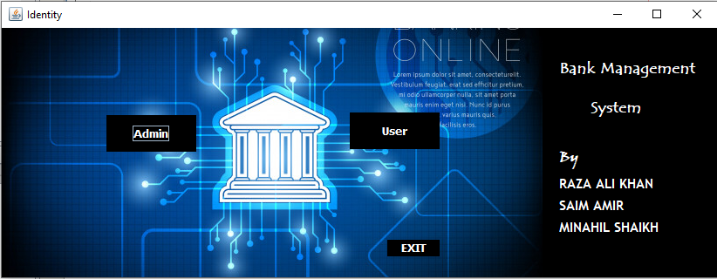

**LOG IN:**

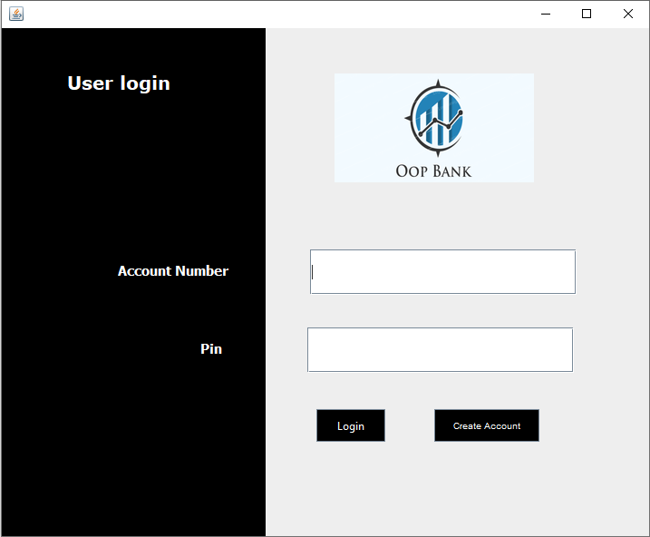

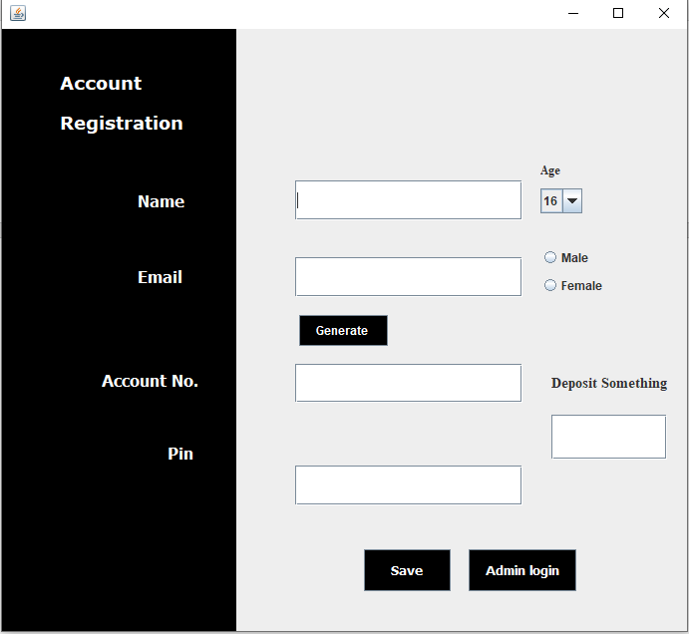

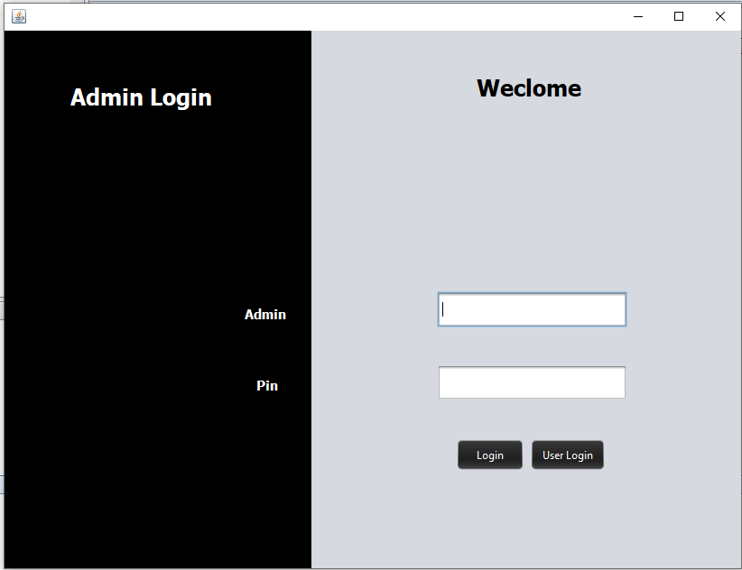

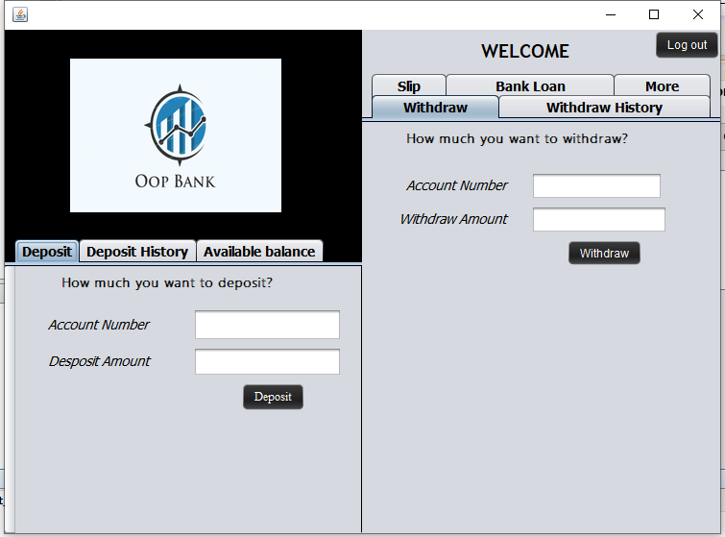

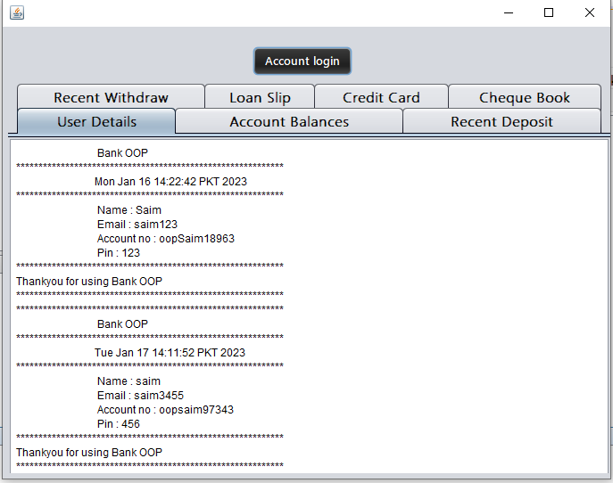

Conclusion & Future Enhancement

##### Conclusion

Bank management system is a virtualization of transactions in banking system. The banking system are used manual working but when we used online banking system it is totally virtualization process which avoid manual process and converts it in automatic process .